GOLFER REGISTRATION FORM
Primary Golfer in Group:
NAME:_________________________________
ADDRESS:____________________________________________________________________
PHONE: ( ) ________________________
EMAIL:________________________________
OTHER PLAYER NAME(S):

Indicate number of people for each:
___ Golf and Dinner ($175 per person)
___ Bus Transportation (add $25 per person)

Method of Payment:
Cash: $___________
Check #: __________Amount $_________
Venmo: @Bob-Karpowicz (please indicate “The Louie Open” and for which golfers you are paying).

Make checks payable to “Rutherford Fire Engine Co. No. 2, Inc.” Please send payment and completed form before September 15, 2022 to:

The Louie Open
Rutherford Engine Co. No 2, Inc.
400 Mortimer Avenue
Rutherford, NJ 07070

You may register and pay online at: http://www.thelouieopen.com

We will have bus transportation available for an additional $25. If you plan on having some alcoholic beverages, we encourage you to take the bus or have a designated driver. For further info, please contact Bob at (201) 522-9939 or Justin (848) 459-2609.

In February 2016, we lost one of our beloved members suddenly. He was a retired member, our vice-president, father, golfer, but most importantly, he was our friend. He is greatly missed. Lou was instrumental in planning past golf outings and showing the younger guys how to run a golf outing. He also helped us out with various fire department functions, even in retirement. As a way of honoring Louie, Rutherford Fire Engine Co. No. 2, Inc renamed our annual golf outing in his honor.

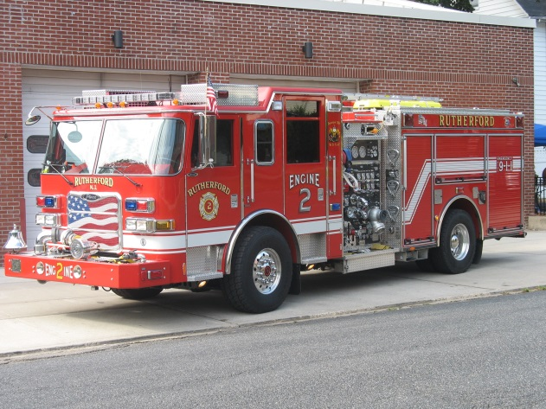
Rutherford Fire Engine Co. No. 2, Inc. is a registered 501(c)(3) charitable organization with the Internal Revenue Service. Our Federal EIN is 26-2166103. We are also a Registered Charity with the State of New Jersey, Division of Consumer Affairs Charitable Registration. Our Charitable Registration Number CH-31116-00

Rutherford Fire Engine Co. No. 2
proudly presents
The 7th Annual Louis S. Eberspeacher Memorial Golf Outing
a.k.a “The Louie Open”
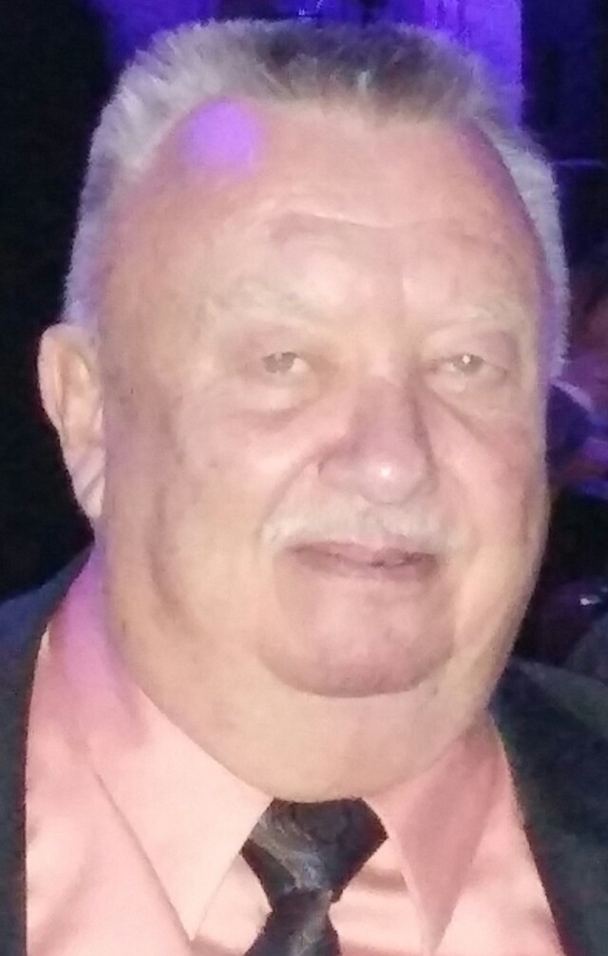
** NEW LOCATION **
Flanders Valley Golf Course – Flanders, NJ
Saturday, October 1, 2022
Registration & Continental Breakfast 10:00 am
Grille Lunch at the turn.
Tee Time: 12 noon - Shotgun Start
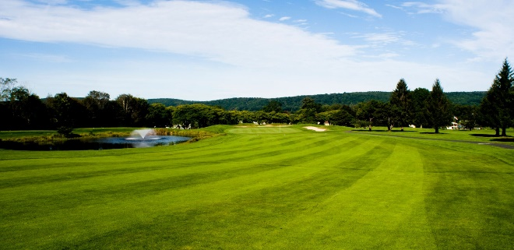
A change of venue this year as Rutherford Engine Co. No. 2, moves the outing 20 miles closer to home to the Flanders Valley Golf Course in Flanders, NJ for our 17th annual golf outing. This outing is special to members of Engine 2 as the outing was renamed after retired member Louis Eberspeacher, who died suddenly in February, 2016.
Registration will begin at 10:00 a.m. Each golfer will receive a small goodie bag at registration. A continental breakfast will be served starting at 10 am with a Grille lunch provided at the turn. Golf will start at 12 noon and will be a shotgun start. The format for the Louie Open will be a scramble format. We will be playing on the Gold/Red course.
There will also be opportunities to win prizes for a hole in one at each of the four Par 3 holes, including a chance to win a new car for a hole in one! The beverage cart will be on the course for all of your hydration
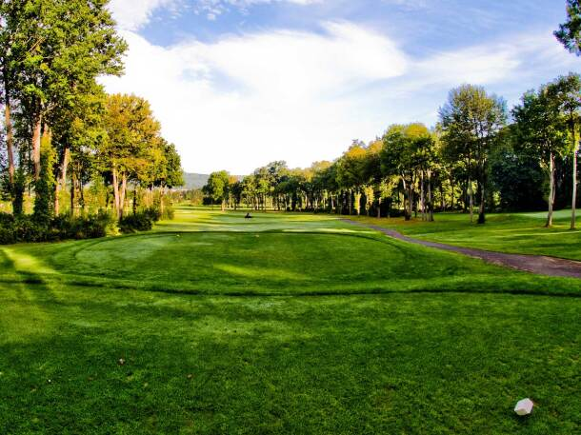
needs. Two ¼ kegs will also be available on-course.
Upon completion of golf, please drop off the scorecard in the pro shop. An awards dinner will be held back at the Mortimer Avenue Firehouse. Door prizes, raffles and awards will be given out. Awards will be given for the Lowest Team Score, Closest to the Pin, and Longest Drive. 50/50 and raffle prize ticket sales will be available at registration and again during dinner.
Please listen to the starter and follow their instructions. This is a new course to us. We ask that you respect the course. Please do not litter and use the trash receptacles. Please keep up the pace of play. We strive for a 4 1/2 hour round. USGA rules govern when local course rules do not apply. Please do not damage golf course property and respect employees of the course.

Additional information may be available after the printing of this form.

SPONSORSHIP LEVEL FORM:
There is a sponsorship for EVERY budget.
__ Hole Sponsor - $100 per sign
Your business card blown up to approx.
8.5” x 11” sign at Tee Box.
__ Trophy Sponsorship - Your business name
engraved on the trophy (first come, first served. Call to reserve space).
__ Closest to the Pin - $150
__ Longest Drive - $120
__ Low Team Score - $80/trophy, up to 4
__ Practice Range Sponsor - $200
Two Signs displayed at top of entrance to the driving range.
__ Putting Green Sponsor - $200
Two Signs displayed at putting green.
__ Golf Cart Sponsor - $300
Your business name or picture of your
business card displayed in all of the outing golf carts in a 4” x 6” advertising space.
__ Beverage Cart Sponsor - $250
Your business name or photo of your business card blown up to approx. 8.5” x 11” sign displayed on the beverage cart.
__ Dinner Sponsor - $1,000
Your business cards and other advertising
information (you supply) placed on each table and a foursome for golf.
__ Bus Sponsor - $1,000
One golfer and signage on the bus, plus any advertising material you supply for each seat.
__ Food/Prize Sponsor
DONATE food, prizes or gift certificate/gift card from your business.
Please see reverse side for payment remittance information and to complete golfer information.

