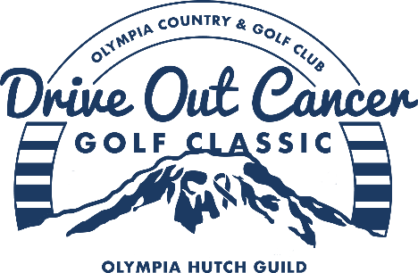

It is heartening to live in a community that joins together in support of a worthwhile cause. Our recent Drive Out Cancer Tournament set a goal of raising $100,000 for the Olympia Hutch Guild. We worked in partnership with the Guild and had over 130 participants comprised of club and community members (even folks from Chicago) in the event and more than 30 volunteers helping make it a successful day. We were able to raise more than $130,000 to fuel hundreds of Fred Hutch laboratories and projects working to prevent, treat and cure cancer, COVID-19 and other diseases.
Our Olympia Country and Golf Club staff worked hard to make this a great experience for all who attended. The food was amazing (lunch, cocktail party and dinner). There was an opportunity for people to dedicate a memorial sign to loved ones who have lost the fight to cancer. Over 100 pinwheels outlined the putting green with names of family and friends who are in the battle with cancer, have survived cancer or who have been taken by this disease. Golf carts were adorned with flags highlighting our Drive Out Cancer logo. Our Pro, Mitch Berschauer, hit over 100 golf balls onto the first green (for a donation of $10). No one was able to score a hole-in-one to win a car (sponsored by I-5 Cars) – but many took home raffle baskets or prizes for KP, longest and most accurate drives. The day was filled with fun, love and a few tears.
Our committee was fantastic and needs a special thanks for all their hard work. The planning began in November of 2021 and being a first-time endeavor involved many volunteer hours. A special thanks to club members Nancy Bean, Mitch Berschauer, Josh Bridge, Shelley Foltz, Jacki Gavin, Julie Goldsmith, Mark Jensen, Renee Lewis, Sandy Parry, Laurel Seaman, Arel Solie, Craig Stephens, Robb Weller, and Susan Wilson. The Olympia Hutch Guild Board members Christine Alexander, Cheryl Duryea, and Lorraine Hamilton also provided support to make this a successful event.
And of course, we must thank our sponsors! Their generosity ensured that we met our fundraising goal. Join us in thanking Forma Construction, Harbor Food Service, Donedei Wines, I-5 Cars, L & E Bottling, Port Blakely, The Rants Group, William Pope, Olympia Federal Savings, Capital Electric, Kaufman Real Estate, Kaufman Holdings, Coldwell Banker, Sunset Air, Gastroenterology Associates, Office Bar & Grill, Commencement Bank, Turning Leaf Productions, Van Tuinen Art, Weller Productions, JungleBri, Print NW, and Panowicz Jewelry.
With all this financial support, the Fred Hutch staff are unlocking how cancers start and spread and harnessing the immune system to fight disease. This work is helping to make treatment more equitable and accessible for more people. Together we are making a difference!
Mark Your Calendars for NEXT YEAR – August 26th, 2023!!!
Olympia Country and Golf Club
Drive Out Cancer Committee

Photo Highlights
