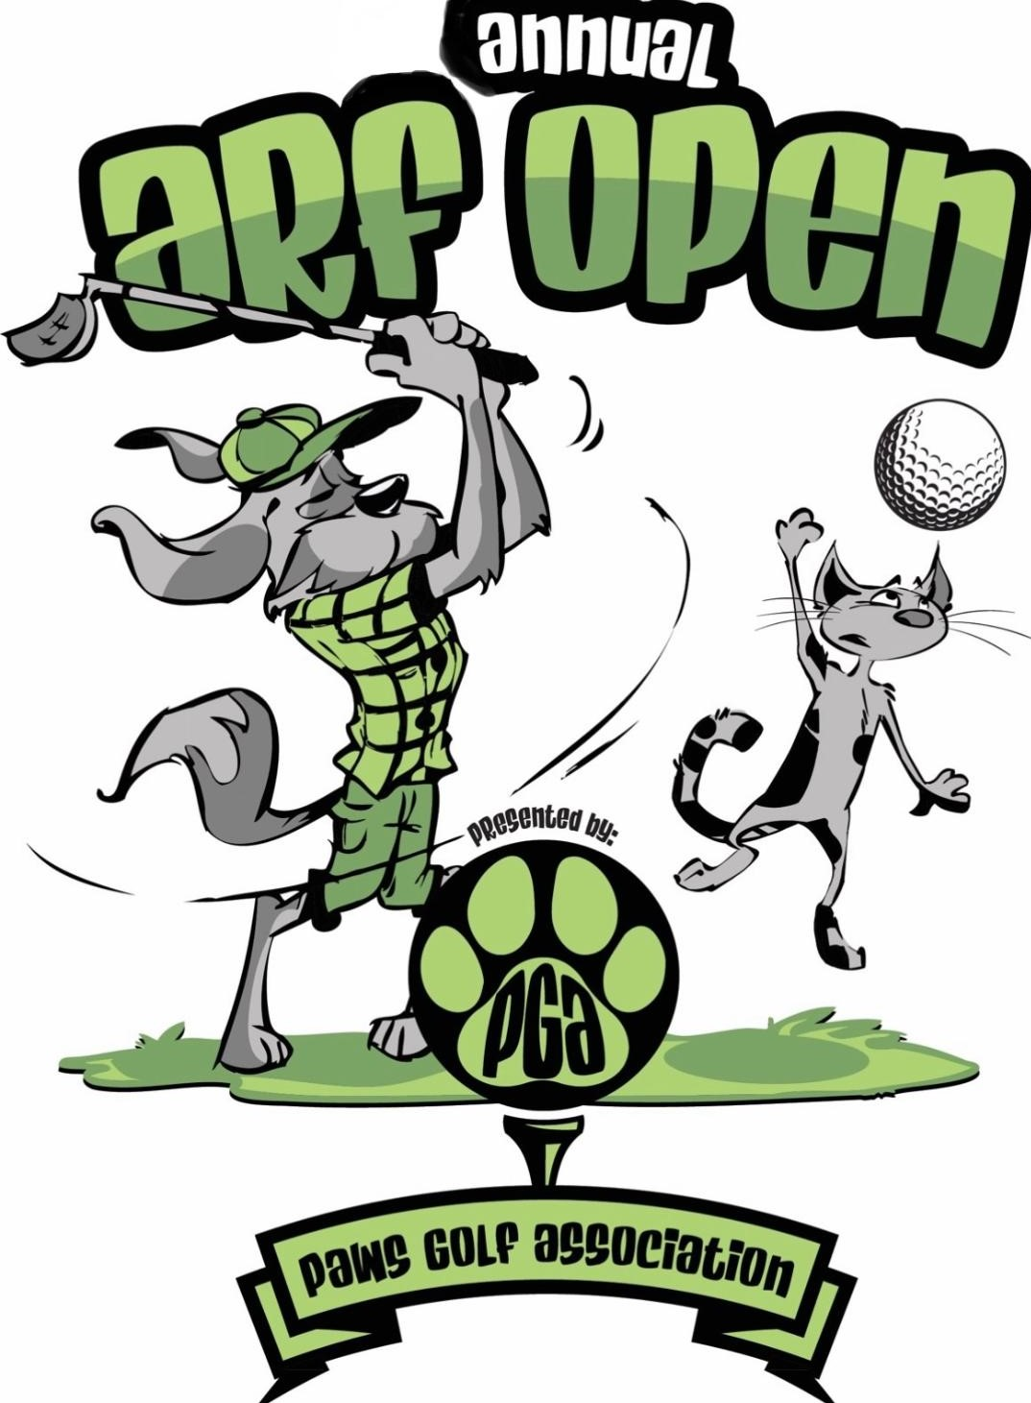

Friday, July 21, 2023
Adams Municipal
Golf Course
Bartlesville, Oklahoma
Register at arfpga.com

Team Entry - $500
Individual Entry - $125
18 holes, golf cart
& lunch!

4 Man Scramble
Shot Gun Start 8:00am
FREE Mulligan per entry
Prizes for 1st, 5th, 15th
Closest to Pin
Longest Drive
50-50 Raffle
Gift Basket Raffle

Unique twists at each hole! Examples…
“Play Fetch”…after the tee shot everyone must throw their ball until they land on the green and putt out.
“Get Your Toy”…once you reach the green, swap your golf ball with a tennis ball and putt out.
“Tea Time”…grab a whole bag of tees, you get to tee up every time!

Register at arfpga.com
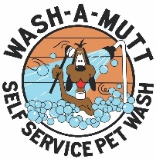
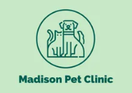
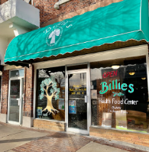
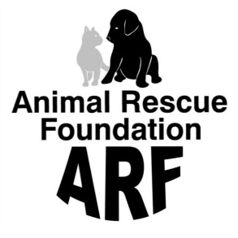
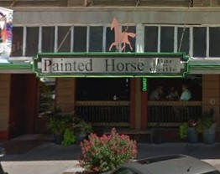

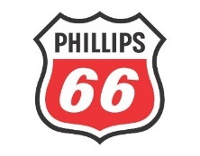
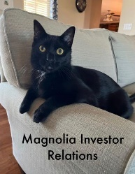



Sponsorship Levels:
- Top Dog - $3,000 – 3 team entries, name on event banner & all media
- Big Dog - $2,000 – 2 team entries, name on event banner & all media
- Mighty Dog - $1,000 – 1 team entry, name on event banner & all media
- Hot Dog - $500 – Hole sponsor with name on hole & event banner
- Under Dog - $250 & under – in-kind donations
- Lazy Dog – Unable to participate but here’s a donation!
Other ways to help:
- Beverage Cart – advertising on cart & website
- Web $300 (1) – advertising on website
- Prizes - advertising on website & all media
- Lunch (~100 people) – advertising on website & all media

