
Announcing the
2023 Texwipe
Cleanroom Classic
Supporting the United Way of Forsyth County
and United Fund
of Surry

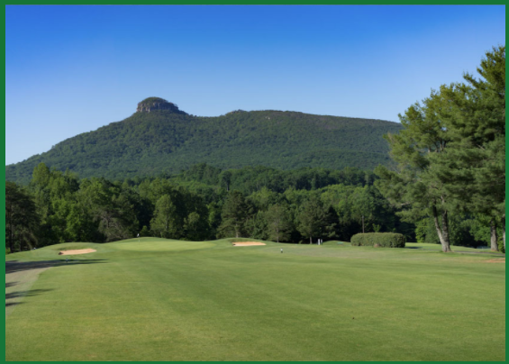
2023 will be the 21st edition of the Cleanroom Classic supporting our local communities. The response to holding our event locally in Pilot Mountain, NC has been so overwhelmingly positive from the community and participants that we are announcing year 3 at Pilot Knob Park Golf Club.
Since our humble beginning in 2002, the generosity of our participants, sponsors and community friends supporting the golf outing has enabled the contribution of over $400,000 to both Forsyth County United Way and The United Fund of Surry County directly related to the golf outing. We hope to surpass last year’s total in 2023 as the needs of the community unfortunately have not gone away. Surry County has a population of approximately 70,000 residents and over 25% used a service associated with the United Fund. Forsyth County has a population of approximately 388,000 and over 36% used a service associated with United Way.
It is with this in mind that we hope to make our 21st year the very best by you joining us for a day of fun, fellowship and most importantly – fundraising. We look forward to seeing all our old friends from years past and hopefully many new friends. Please pass this along to make this event fabulous.
For further information and official sponsorship and registration forms visit our golf website by clicking here.
Sincerely Texwipe Golf Committee
Sincerely

Texwipe Golf Committee
Thank You to Our 2022 Sponsors
Views of Pilot Knob Park Golf Course

