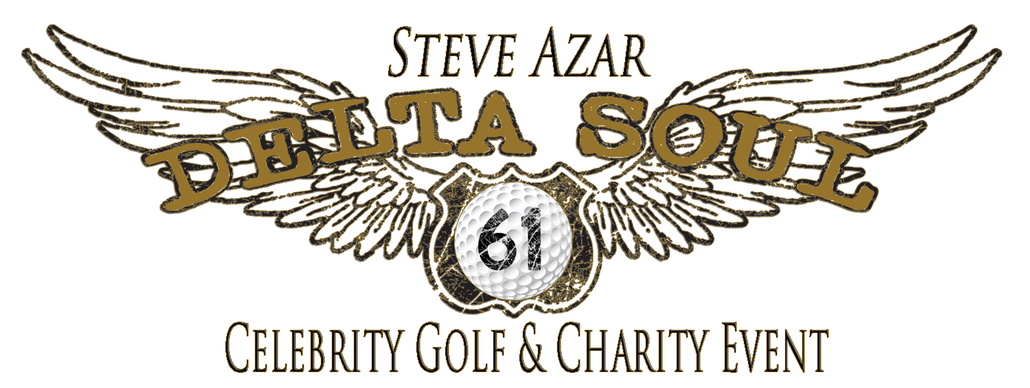

2018 Detailed Schedule of Events
Schedule Subject To Change – Please Confirm Upon Arrival
JUNE 7 - THURSDAY
12:00 – 6:30 p.m. Sponsor Packet Pick Up and Registration
The Lofts Lobby / Greenville Inn & Suites Lobby Or do leyser gallery

6:30-8:00 p.m. Welcome Happy Hour & Celeb Cup Pairings Party*
Juke Joint hospitality room-Leyser Gallery

8:30-10:30 p.m. Doe’s Celebrity Dinner*
Doe’s Eat Place - Casual Attire
10:00 p.m. Blues Bar Jam
Walnut Street Blues Bar - Casual Attire

JUNE 8 – FRIDAY
9:30 a.m. Celeb Challenge Registration & Check-In

11:00 a.m. Celeb Challenge –Tee Off
Greenville Golf & Country Club – Golf Attire

5:00-6:30 p.m. Happy Hour in the Juke Joint*

7:00-11:00 p.m. The Big Night Dinner & Live Auction Party*
Outdoor at the Home of Dr. & Mrs. Joseph Terracina-Dressy Casual

11:30 p.m. Late Night Snack in the Juke Joint*
JUNE 9 - SATURDAY
9:30 a.m. Delta Soul Championship Check-In
11:00 a.m. Delta Soul Championship Tee Off
Greenville Golf & Country Club – Golf Attire

7:00-8:30 p.m. Catfish Fry Dinner*
Greenville Inn & Suites Courtyard – Casual Attire

9:30 p.m. Somethin’ in The Water Block Party*
Walnut Street and Main – Outdoor Casual Attire

Midnite Late Night Snack in the Juke Joint *

*Ticket and/or VIP Sponsor Credential Required
PLEASE REFER TO YOUR SPONSORSHIP LEVEL TO SEE WHAT

