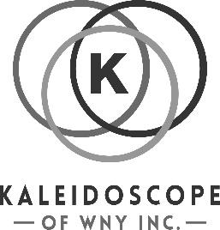
Kaleidoscope of WNY, Inc.
Golf Tournament
Sponsorship Form

Benefiting Kaleidoscope of WNY, Inc. Online registration/donation:
September 14, 2024 * Chestnut Hill Country Club Kscopewny.org

We have several opportunities to sponsor and support the first annual charity golf tournament to benefit Kaleidoscope of WNY, Inc. See below for sponsorship registration.

SPONSOR CONTACT INFORMATION
Name/Title: _____________________________ Company Name: _________________________
Address: ________________________________ City/State/Zip:___________________________
Email: __________________________________ Phone: _________________________________

SPONSORSHIP OPPORTUNITY
▢ Tournament Sponsor-$1,000 includes 1 complimentary foursome, logo displayed at check in, event site, social media
▢ Dinner Sponsor-$500 includes logo displayed at dinner, social media
▢ Hole-$150 – name of company displayed at a hole
▢ Donate to silent Auction/Raffle -we would appreciate donations by August 15, 2024.
▢ Free Will offering: $________________
▢ Contest Prize Donation: ________________________________________________

SILENT AUCTION/RAFFLE DONATION
Description of item:________________________________________________________________
Expiration Date: ___________________________
Value of Donated Item: $ ____________________

▢ Please check here if you need Kaleidoscope of WNY, Inc. to pick up the item.

▢ I will drop off my donation to:
Kaleidoscope of WNY, 555 Como Park Boulevard, Cheektowaga, NY 14227.

Please make checks payable to : Kaleidoscope of WNY, Inc. and mail to:
Kaleidoscope of WNY, Inc.
Beverley Britzzalaro
5616 Strickler Road
Clarence, NY 14031

Email: Kaleidoscopeofwny@gmail.com

