12TH ANNUAL MHPD



Golf Tournament & Fundraiser

Friday, October 17, 2025
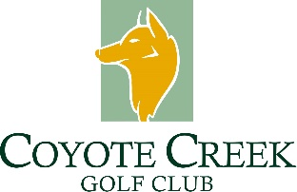
Check-in 10:30 A.M. at Clubhouse
Shotgun Start at 12:00 P.M.

ENTRY FEE: $200 per player

Includes: Green fees, cart, range balls, box lunch and dinner buffet. Winning Team Trophies, Hole-In-One prize, Longest Drive & Closest to the Pin trophies.
Raffle prizes include drivers, putters, wedge sets, golf bags and more.

Raffle tickets $1 each or 25 for $20 (See website for more options.)

100% of the proceeds from the tournament will benefit the Morgan Hill Cops for Kids Foundation. The mission of the foundation is to foster relationships between law enforcement and youth in the Morgan Hill community. We are a non-profit 501(c)(3) organization.
We always accept (and need) fun raffle prize donations!

For more information, and to register, go to www.mhcopsforkids.com



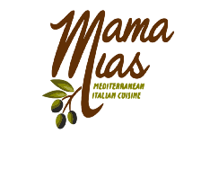

TOURNAMENT SPONSORSHIPS
Support Morgan Hill Cops for Kids Foundation by being a tournament sponsor.
TOURNAMENT SPONSORS
TOURNAMENT SPONSOR $5000
Top Dog! Everyone will see your logo all over the place! Includes company name & logo on website and promotions at event, sponsorship plaque to display at your place of business, tee marker, 3 complementary foursomes and a center table reserved for dinner. Also includes golf polo shirts (with the Cops for Kids logo imprinted) for each player.
PLATINUM SPONSOR $2500
Includes company name & logo on website and promotions at event, sponsorship plaque to display at your place of business, tee marker, 2 complementary foursomes and a reserved table for dinner.
GOLD SPONSOR $1500
Includes company name & logo on website, promotions at event, tee marker, and a complementary foursome.
SILVER SPONSOR $500
Includes company name and logo on website & promotions at event. Tee marker.
BRONZE SPONSOR $250
Includes company name and logo on website.

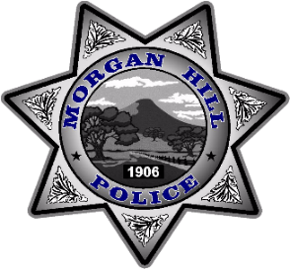
Friday, October 17, 2025
Register on-line – www.mhcopsforkids.com
Registration Form
Players must pre-pay to be registered.
Name:

Email Address:

Phone Number:

Golfer #1:

Golfer #2:

Golfer #3:

Golfer #4:

PAYMENT:

Golf Fee $200 x = $
Number of Golfers Total Golf Fees

Sponsorships: Top sponsor $5000 (please check website)

Bronze $250 Silver $500 Gold $1500 Platinum $2500

TOTAL PAID: $

THANK YOU FOR YOUR SUPPORT!!
Team Rosters will be accepted until we sell out. Don’t delay as we sell out every year. Payments can be made online at www.mhcopsforkids.com or send your registration form and check to
MH Cops for Kids Foundation, PO Box 961, Morgan Hill, CA 95038.
Any questions? mhcopsforkids@gmail.com

