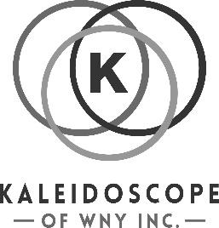
Kaleidoscope of WNY, Inc.
Golf Tournament
Sponsorship Form

Benefiting Kaleidoscope of WNY, Inc. Online registration/donation:
September 13, 2025 * Chestnut Hill Country Club Kscopewny.org

We have several opportunities to sponsor and support our annual charity golf tournament to benefit Kaleidoscope of WNY, Inc. See below for sponsorship registration.

SPONSOR CONTACT INFORMATION
Name/Title: _____________________________ Company Name: _________________________
Address: ________________________________ City/State/Zip:___________________________
Email: __________________________________ Phone: _________________________________

SPONSORSHIP OPPORTUNITY
▢ Tournament Sponsor $2,500-Includes 1-complimentary foursome, logo display at check-in, 1-hole sponsor sign, recognition on the event website, and shoutouts on social media.
▢ Dinner Sponsor-$1000-Includes 1-complimentary foursome, 1-hole sponsor sign, logo featured during dinner, and recognition on social media.
▢ Beverage Cart Sponsor-$500 Your company name will be displayed on beverage carts throughout the event, plus social media recognition.
▢ Hole-$150 – Your company name will be displayed at one of the tournament holes.
▢ Donate to silent Auction/Raffle -We welcome your generous donations by August 15, 2025.
▢ Free Will offering: $________________
▢ Contest Prize Donation: ________________________________________________

SILENT AUCTION/RAFFLE DONATION
Description of item:________________________________________________________________
Expiration Date: ___________________________
Value of Donated Item: $ ____________________

▢ Please check here if you need Kaleidoscope of WNY, Inc. to pick up the item.

▢ I will drop off my donation to:
Kaleidoscope of WNY, 555 Como Park Boulevard, Cheektowaga, NY 14227.

Please make checks payable to : Kaleidoscope of WNY, Inc. and mail to:
Kaleidoscope of WNY, Inc.
555 Como Park Boulevard * Cheektowaga, NY 14227

Email: Kaleidoscopeofwny@gmail.com

