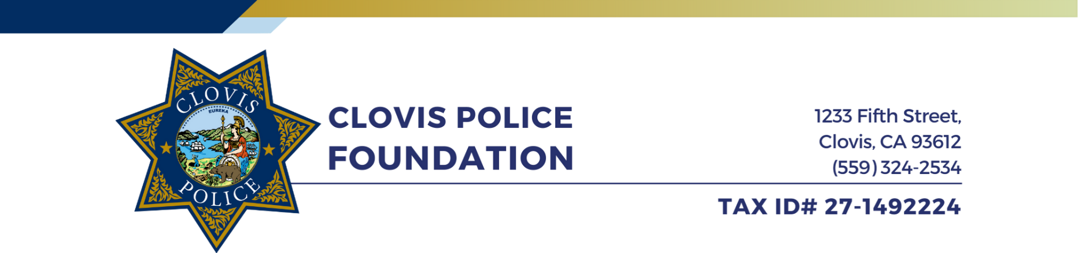


1233 Fifth Street
Clovis, CA 93612
(559) 324-2534
TAX ID# 27-1492224
CLOVIS POLICE FOUNDATION
GOLF TOURNAMENT

We cordially invite you to be part of this year’s Clovis Police Foundation Golf Tournament, our flagship fundraising event that helps support several community programs and activities provided by the Clovis Police Department (CPD) including the Cops and Kids Camp, Clovis Police Youth Academy, K-9 Program, Chaplain Program, and so much more.

This year’s tournament will be on Friday, September 12, 2025 at Eagle Springs Golf & Country Club. It will be a shotgun start beginning at 9:00 am, with check-in as early as 7:30 am. All teams receive breakfast, lunch, 2 golf carts, a gift bag for each golfer, and raffle tickets. Additional raffle tickets can be purchased that day.

We are seeking several sponsors to help fund this event so more proceeds can go back to our community programs. We anticipate a sold-out tournament with 144 players, and there are many opportunities for you or your business to be recognized:

BENEFIT | BLUE LINE SPONSOR  $5,000 | PLATINUM SPONSOR  $3,500 | GOLD SPONSOR  $3,000 | SILVER SPONSOR  $2,000 | BRONZE SPONSOR  $1,500 | FOOD SPONSOR  $1,000 | HOLE SPONSOR  $200
Exclusive Day Experience with CPD | CPD SWAT |  | CPD  K-9 Unit
Logo on Three Ball Golf Sleeve in Participant Swag Bags |  | 
Complimentary Four (4) Person Team Entry
Facebook Recognition Posts |   X3  X3  X3  X3  X1
Logo on Event Banner
Signage at Food / Beverage Location
Name and Logo on Hole(s) | X3 | X3 | X3 | X3 | X3 | X1 | X1

Each sponsorship level offers a unique opportunity to highlight you or your business, and your sponsorship truly makes a difference. We hope you join us in support of this noble cause and have some fun while you do it! Registration can be completed online at clovispolicefoundation.com.

Respectfully,

The Clovis Police Foundation Board of Directors

For more information, please contact Marissa Venegas at (559) 324-2490. Checks may be mailed to The Clovis Police Foundation, 1233 Fifth Street, Clovis, CA 93612.

