The 8th Annual Clipper Cup
2025
Barbers of the Lowcountry raising money for:
The Clipper Foundation,Inc.
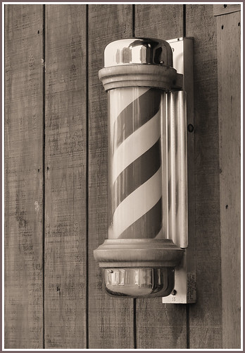
Sponsorships

Pompadour Sponsor
$2,000
- ONLY 1 Left!!!
- Name & logo displayed on banners at clubhouse
- 1 Sign on tee & flag on green
- Ads in practice area
- 1 foursome
- Recognition in event marketing
- Recognition on t-shirts
Fade Sponsor
$1,200
- 1 sign on tee & flag on green
- Ads in practice area
- Recognition in credits
Buzz Sponsor
$500
- 1 sign at tee and flag on green
- Recognition in credits
Prize Sponsor
$400
- Sponsor a prize for one of the contests
- Recognition in credits

Ball Sponsor
SOLD OUT
$1,500
- Logo on golf balls
- 1 sleeve/player
Cart Sponsor
$750
- ONLY 2 AVAILABLE!!!
- Ads on ½ of carts

AR-15 Sponsor
$650
SOLD OUT
- Only 1 AVAILABLE!
- Ar-15 GUN hole sponsor with your name on the hole.
- Includes a hole sponsor.

Barbers of the

Lowcountry

Clipper Cup Golf Tournament
Raising money for The Clipper Foundation,Inc
Saturday, November 1, 2025
The Crescent Pointe Golf Club

SPONSORSHIP SIGN-UP
Cost
Sponsorship Level ___________________________ $
Sponsor Information
Name ___________________________
Address ___________________________
___________________________
Point of Contact
Name ____________________________
Email ____________________________
Phone ____________________________

I would like to donate an additional amount toward Bluffton
Self Help. $

TOTAL ENCLOSED: $
Please email any hi-res images for banners or hole signs to info@barbersofthelowcountry.com

I understand that if I do not email my logo and/or any information needed for a banner or hole sign sponsor by 10/15/25, then Barbers of the Lowcountry, Inc and its marketing team reserve the right to design my banner as they see fit.
*Please Make checks payable to Barbers of the Lowcountry

Signature:______________________________________________ Date:________

