  FUQUAY VARINA LIONS CLUB  30TH GOLF TOURNAMENT  BENTWINDS GOLF & COUNTRY CLUB  MONDAY, APRIL 27TH 2026  There is nothing quite like a crisp Carolina morning at Bentwinds Country Club, especially when you are teeing off for an incredible cause!  By participating, you will help support remarkable projects such as KidSight Vision Screening, scholarships for deserving graduates, Camp Dogwood for individuals with vision loss, the V.I.P. Fishing Tournament (Visually Impaired Persons) & many more.  Every penny you give directly benefits those in need.  How You Can Help  - Register solo or round up a team of friends and colleagues.  - Looking into sponsorship opportunities.  - Spread the word. |  |  | Goog Gold Presenting Sponsorship  Get a Hole Sign and acknowledgment on the website (includes live link).  Get a Team of 4 players.  Silver Sponsorship  Get a Team of 4 players.  Get a Hole Sign and acknowledgment on the website (includes live link).  Bronze Lion David Stuart Scholarship  Get a Hole Sign and acknowledgment on the website, including a live link.  Two scholarships are awarded annually.  Hole Sign and Web Advertisement  Price: $300.00 (USD). Hole sponsor includes a live link on the website and a Hole Sign.  Longest Drive Sponsor Men  The longest drive for men will take place on hole #5.  Longest Drive Sponsor Women  longest drive for women will take place on hole #10.  Longest Putt Hole #18  Special Signage and acknowledgment on website (include a live link).  Closest To the Pin Sponsor  Special Signage and acknowledgment on website (include live link).  Mr/Ms Mulligan With Corporate Logo  Beverage Cart Sponsor  Provide branding on carts circulating throughout the event, maximizing your company’s visibility.
  Best regards,
  Information:
  fvlions.president@gmail.com
  To Register fvlionsgolf.org.
  
  KidSight Program:
  The KidSight Program offers free vision screenings—not full eye exams—for children aged 6 months to 7 years, provided by the Lions Club. The leading cause of preventable vision loss in the U.S. is amblyopia, and KidSight screenings can help identify this, along with several other issues.
  Peace Poster Contest:
  Lions’ clubs worldwide have invited children to participate in a special art contest held in schools and youth organizations.
  Camp Dogwood:
  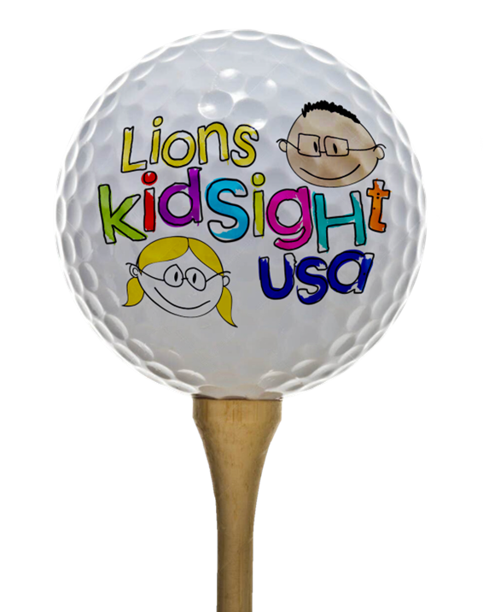
  Camp Dogwood stands as a cornerstone of our charitable initiatives, offering a vibrant retreat specially designed for individuals with visual impairments. Run by the North Carolina Lions Club Foundation, this program welcomes adults from across the state who are blind or visually impaired, providing them with a supportive and enriching environment.

  FUQUAY VARINA LIONS CLUB  30TH GOLF TOURNAMENT  BENTWINDS GOLF & COUNTRY CLUB  APRIL 27TH 2026  Entry Fees Include:  Golf Cart * Prizes * Breakfast Biscuits* juice* coffee * Lunch provided * drinks * snack carts  Check-in 8 a.m. shotgun tee off 9 a.m.  NAME: ______________________________  Address: ____________________________________  Phone: ____________________________________  Email Address: ____________________________________  TEAM REGISTRATION  Please Print Name and Include Player’s Handicap Index or Avg. Score  TEAM NAME: ____________________________________  PHONE: _____________________________  Team Contact: _______________________ |  | PLAYERS  Player 1 ______________________________________  Email Address _________________________  Player 2 ______________________________  Email Address _________________________  Player 3 ______________________________  Email Address _________________________  Player 4 ______________________________  Email Address _________________________  Costs / SPONSORSHIPS  Per Player: $115 $_________  Team of 4 $460 $_________  Mulligan (Extras) $10 EACH $__________  FREE 1 PER PLAYER  Hole Sign and Web Ad $300.  Gold Presenting Sponsorship $2,500  Silver Sponsorship $1,500  Bronze Lion David Stuart Scholarship $500  Longest Drive Sponsor Men $400  Longest Drive Sponsor Women $400  Longest Putt Hole #18 $400  Closet to the Pin $400  Beverage Cart Sponsor $400  Mr/Ms Mulligan with Corporate Logo $400 |  | Longest Putt Hole #18 $400  Closet to the Pin $400  Beverage Cart Sponsor $400  Mr/Ms Mulligan with Corporate Logo $400  Make Checks Payable to the F-V Lions Club. Mail payment along with Registration form to:  FV Lions Club  P.O. Box 117  Fuquay-Varina, NC 27526 | Checks Payable to the F-V Lions Club.  Options:  - Mail payment along with Registration form to:  FV Lions Club  P.O. Box 117  Fuquay-Varina, NC 27526  - Go to fvlionsgolf.org and signup online.
  Type a caption here for the photos
  