2026 Putting for Petra Volunteer Kit
(this document can be downloaded in its entirety at https://puttingforpetra.com) (Menu/File Downloads)

2026 Volunteer Committee (at March 1)
Doug Murray (Frosty) – doug.murray@colliers.com
Jen Murray – chilowak@yahoo.com
Mike Shamber (Shamwow) – mshamber905@gmail.com
Karen Hauser – littlhauser@gmail.com
Cari Gangaram – carigangaram@rogers.com
Claudia Tremblay – ctpt92@gmail.com
Kelly Hine – shine@cogeco.ca
Sonya Stevenson – sonya.stevenson@ontario.ca
Dee Dee Morgan – deedeemorgan1000@gmail.com
Sonia Jarego (remote) – 44sonia@live.com
*Please feel free to invite anyone else to participate. The more the merrier!

Committee Meeting Schedule (calendar invites to be sent shortly)
Mon Mar 2nd @ 7pm – in person kickoff at Jersey’s. Agenda: Fundraising
Mon Apr 6th @ 7:30 pm – via MS Teams. Agenda: Fundraising
Mon May 4th @ 7:30 pm – via MS Teams. Agenda: Fundraising
Mon Jun 1st @ 7:30 pm – via MS Teams. Agenda: Fundraising and onsite logistics
Fri Jun 19th @ 7pm – in person at Jersey’s. Agenda: Onsite Logistics

Prize Ideas (ideally min $50 in value, however we will repurpose if less):
• Gift cards or gift baskets
• Restaurant or dining experiences
• Golf-related items or experiences
• Sports or event tickets
• Wellness, fitness, or spa services
• Professional services
• Unique local experiences or products
Additional Opportunity:
• Special Online Auction to take place prior to tourney for items/experiences with value over $2000 – Allows greater profile for donor, and exposure outside golfers/guests. For example, Air Canada Vacations.

Non-local businesses to target
Many large companies have a philanthropic arm or foundation easily found online, and can provide an easier ‘yes’ – someone just needs to take the initiative to make the ask. Note that Corporate teams love education, scholarships, and youth advancement.
For instance - Air Canada Foundation – provides Aeroplan points/flight vouchers/weekend stays
Some of the obvious ones are:
Air Canada
Westjet
Telus
Rogers
Bell
Banks
Walmart
Costco
Home Depot
But there are likely hundreds out there.

Volunteer Resources

Prize Tracking Google Sheet
This prize tracking sheet shows 2024-2025 prize donors and who on the committee handled the approach. The sheet also allows us to track our 2026 efforts. Please keep updated as you reach out so that efforts are not duplicated. Updates can be sent to Mike Shamber at mshamber905@gmail.com

Putting for Petra 2026 Flyer (high res .pdf file downloadable at https://puttingforpetra.com)
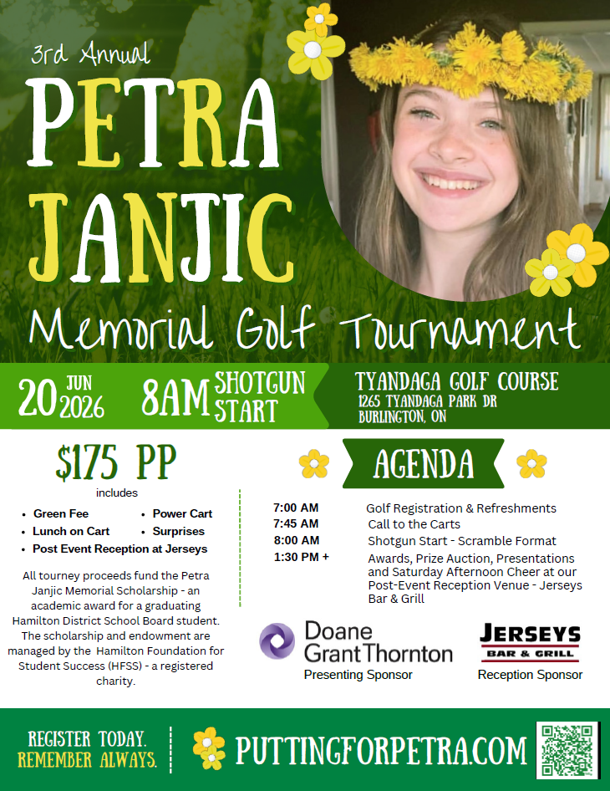

Sample Formal Letter
[Date]
Dear Community Partner,
We are reaching out to invite your business to support Putting for Petra, a growing community charity golf tournament held in memory of Petra Janjic.
Petra passed away from cancer shortly after graduating high school, before beginning university. This event was created to honour her spirit of kindness, perseverance, and deep connection to her community, transforming loss into opportunity for others.
What began as a tribute has quickly grown into a meaningful annual tradition bringing together local families, businesses, and community leaders to make a lasting impact. In just two years, Putting for Petra has raised more than $100,000 in support of the Petra Janjic Memorial Scholarship, helping local students pursue their educational goals and future aspirations.
As we prepare for this year’s tournament at Tyandaga Golf Course, we are seeking support from valued community businesses through prize and silent auction donations. Contributions such as gift cards, products, services, or unique experiences play a vital role in helping us maximize fundraising and enhance the event experience for participants.
Donating businesses will be recognized as community supporters through event promotions and on-site acknowledgements, demonstrating your commitment to local youth and education.
We invite you to learn more about the event, its impact, and Petra’s story by visiting:
www.puttingforpetra.com
We would be honoured to include [Business Name] among the supporters helping us continue Petra’s legacy and expand the impact of this event.
Thank you for your consideration and for supporting our community.
Sincerely,

Putting for Petra Organizing Committee
www.puttingforpetra.com
Proceeds to Hamilton Foundation for Student Success (Charitable Tax #: 89089 6046 RR 0001)

Sample Email
Subject: Community Support Request – Putting for Petra Scholarship Fundraiser
Hello [Name],
I hope you’re doing well. I’m reaching out as a volunteer supporting Putting for Petra, a community charity golf tournament held in memory of Petra Janjic, who passed away from cancer shortly after graduating high school, before beginning university.
The event was created to honour Petra’s spirit and to create something positive from loss by supporting local students through the Petra Janjic Memorial Scholarship. In just two years, Putting for Petra has raised more than $100,000 to help students pursue their education and future opportunities.
We’re currently inviting local businesses to support this year’s event through prize or silent auction donations, such as gift cards, products, services, or experiences. These contributions play a major role in helping us increase fundraising while showcasing businesses that support our community.
All donors are recognized at the event and associated promotions as valued community supporters.
You can learn more about the event and its impact here:
www.puttingforpetra.com
If [Business Name] would be open to contributing, I would be happy to share details or coordinate pickup or an electronic certificate — whatever is easiest.
Thank you for considering supporting a meaningful local initiative.
Warm regards,
[Volunteer Name]
Putting for Petra Volunteer
[Phone]
[Email]
Proceeds to Hamilton Foundation for Student Success (Charitable Tax #: 89089 6046 RR 0001)

Sample Social Media DM
Hi [Name] — hope you’re doing well! I’m helping organize Putting for Petra, a local charity golf tournament created in memory of Petra Janjic, who passed away from cancer shortly after graduating high school.
The event funds a student scholarship and has raised over $100,000 in the past two years. We’re currently collecting prize and silent auction items from local businesses and wondered if [Business Name] might consider donating a gift card, product, or experience.
You can see full event details here: www.puttingforpetra.com
Thanks so much for considering supporting a meaningful local cause!

Sample Social Media Post
I’m proud to be supporting Putting for Petra ❤️
This community golf tournament was created in memory of Petra Janjic, who passed away from cancer shortly after graduating high school, before beginning university. The event honours her legacy by funding a student scholarship and helping create opportunities for local youth.
In just two years, Putting for Petra has raised over $100,000 for students in our community — and this year we’re hoping to make an even bigger impact.
We’re currently looking for local businesses willing to donate prize or silent auction items (gift cards, experiences, services, or products). If you or a business you know would like to support, please reach out!
You can learn more about the event here:
👉 www.puttingforpetra.com
Thank you to all the amazing community businesses that help make initiatives like this possible 💙
#PuttingForPetra #CommunityStrong #SupportLocal #BurlingtonON #HamiltonON #GiveBack

FAQS

Is this a registered charity?
All proceeds from the golf tournament go to the Petra Janjic Scholarship Fund which is administered by the Hamilton Foundation for Student Success (HFSS), a registered charity.

Where does the money go?
Every year the Petra Janjic Memorial Scholarship presents a graduating Hamilton District School Board student with a single large financial award to assist fund their post-secondary education.

Can I get a receipt?
Currently only cash donations are eligible for charitable receipts for tax purposes.

Who attends?
Friends and family connected to Petra, local business owners, professionals, and community supporters who come together for a meaningful cause. It still has a very personal, community feel, but it’s grown into a well-supported annual event.

How many people?
The golf tournament has approx. 250 golfers and there are another 150 that attend the post-golf reception, so an audience of approx. 400.

How are prize donors recognized?
*logo prominently displayed on landing page of Putting for Petra website (over 1,600 views in 2025).
*logo displayed on prize table sign at silent auction with their logo on Putting for Petra website.
*Marquee Prize Packages will have separate online auction with communication to golfers, sponsors and the general public via social media amplification.

