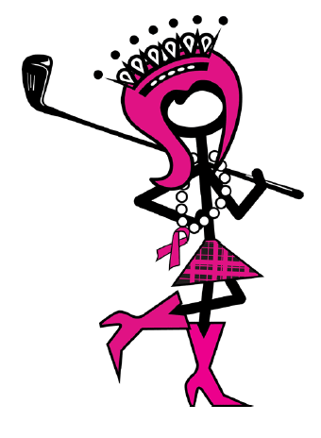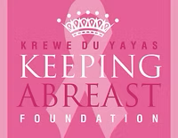

One Stroke Closer to a cure golf tournament 2026

WAIVER, ASSUMPTION OF RISK, RELEASE OF LIABILITY, INDEMNIFICATION, ALCOHOL ACKNOWLEDGMENT, AND PROPERTY RESPONSIBILITY AGREEMENT
I am voluntarily registering for and participating in the One Stroke Closer to a Cure Golf Tournament and any related activities, including golf play, golf cart use, practice areas, contests, meals, social events, and any transportation associated with the event (“Event”).

ASSUMPTION OF RISK
I understand that participation in the Event involves inherent risks, including but not limited to:
- Being struck by golf balls, clubs, or other equipment
- Errant shots or flying objects
- Slips, trips, falls, and uneven terrain
- Weather conditions, including heat, sun exposure, and dehydration
- Golf cart accidents or misuse
- Equipment failure
- Actions of other participants or spectators
- Alcohol-related impairment
- Property damage, loss, or theft
I knowingly and voluntarily assume all risks associated with my participation in the Event, whether known or unknown, foreseeable or unforeseeable.

RELEASE OF LIABILITY
To the fullest extent permitted by law, I release, waive, discharge, and covenant not to sue the Krewe du YaYas, Keeping Abreast Foundation, tournament organizers, sponsors, volunteers, venue operators, golf course owners and operators, and each of their respective officers, directors, members, employees, agents, representatives, affiliates, successors, and assigns (collectively, the “Released Parties”) from any and all claims, demands, causes of action, damages, losses, liabilities, costs, and expenses arising out of or related to my participation in, attendance at, or presence at the Event, including claims arising from negligence, except to the extent prohibited by applicable law.

INDEMNIFICATION
I agree to indemnify, defend, and hold harmless the Released Parties from and against any and all claims, liabilities, damages, judgments, losses, costs, and expenses, including reasonable attorneys’ fees, arising out of or related to:
- My actions or omissions
- My violation of Event, venue, or golf course rules
- My use of golf carts or other equipment
- My consumption of alcohol
- Any claim brought by or through me

ALCOHOL ACKNOWLEDGMENT
I understand that alcoholic beverages may be available at the Event and that consumption is entirely voluntary.
If I choose to consume alcohol, I do so at my own risk and accept full responsibility for my actions and conduct. I agree not to consume alcohol if I am under the legal drinking age and not to operate a motor vehicle or golf cart while impaired.
To the fullest extent permitted by law, I release the Released Parties from any liability arising from or related to the service, consumption, or effects of alcohol.

GOLF CART AND PROPERTY RESPONSIBILITY
I agree to operate any golf cart safely and in accordance with all golf course and Event rules.
I understand and agree that I am financially responsible for any damage to:
- Golf carts and cart accessories
- Golf course property, including turf, landscaping, buildings, signs, fixtures, and equipment
- Property belonging to other participants, guests, or third parties
when such damage is caused by me, my guests, or anyone operating a golf cart assigned to me or under my supervision.
I agree to reimburse the appropriate party for all repair, replacement, restoration, and related costs resulting from such damage.

PERSONAL PROPERTY
I understand that the Released Parties are not responsible for the loss, theft, or damage of personal property brought to or used during the Event, including but not limited to golf clubs, bags, phones, wallets, jewelry, cash, clothing, vehicles, or other belongings, except to the extent caused by gross negligence or other non-waivable conduct under applicable law.

RULES AND CONDUCT
I agree to comply with all Event, venue, and golf course rules, policies, and instructions. The Released Parties reserve the right to deny or revoke my participation or golf cart privileges at any time for unsafe, disruptive, unlawful, or inappropriate conduct.

SEVERABILITY
If any provision of this Agreement is determined to be invalid or unenforceable, the remaining provisions shall fully remain in full force and effect permitted by law.
Consent (Required)
I acknowledge that I have carefully read this Agreement, fully understand its contents, understand that I am giving up certain legal rights by signing it, and sign it voluntarily.

Signature Printed Name Date

