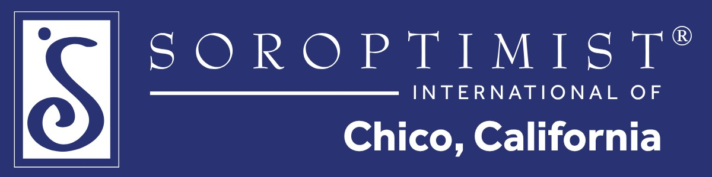
Hello Chico Community Sponsor,
Soroptimist International of Chico is proud to announce our major 2027 fundraiser: the Fifth Annual Charity Golf Tournament, to be held on Monday, May 10, at Canyon Oaks Country Club. Thanks to the community's generous support each year, we have been able to further our mission of empowering women and girls in the North State through a variety of initiatives.
Local nonprofits we support:
- Girls on the Run of the North State
- Ability First Sports
- Boys & Girls Club
- Chico Project SAVE
- Women's Microfinance Collaborative
- Youth for Change
Last year, we awarded over $40,000 in scholarships and community grants.
Grants, awards, and scholarships: CSUC Aging and Gerontology Award, Youth in Service - Violet Richardson Award, multiple Butte College scholarships, and Chico Community Scholarship to name a few. These investments make a meaningful difference in many lives.
We invite you to become a sponsor and help us reach even more women and girls in our community. Sponsorship levels are listed on the back of this letter, along with the benefits your business will receive. We expect more than 100 golfers from across Butte County, and all event proceeds will support our local community. Together, we can make the 5th Annual Charity Golf Fundraiser our most successful yet!
For more information about Soroptimist International of Chico, visit soroptimistchico.org.
To learn more about the golf tournament, visit sichicogolf.com or use the QR code below.

Thank you for your support,

Jill Fountain & Carla Bee
Co-Chairs, SI Chico Fundraising Committee
Soroptimist International of Chico P.O. Box 1812, Chico, CA 95927 Tax ID: 94-6104106 soroptimistchico.org

