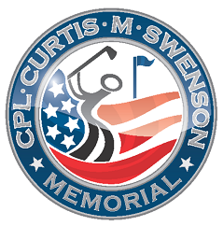
CPL Curtis M Swenson Memorial Fund

4/13/2020

Dear Golfers,

We would like to thank you for making the CPL Curtis M Swenson Memorial Golf benefit a success each year. Under our current medical crisis, we are unfortunately having to cancel the 10th annual event.

Among other projects your donations contribute to: The CPL Curtis M Swenson Scholarship committee is currently working on selecting 5 SE MN students to receive $1000. Portraits are being completed for Fallen Hero’s and support for DAV memberships will be needed more than ever.

We know everyone has different financial situations and would like to offer each group that signed up the opportunity for reimbursement. Please request by May 30, 2020 to: dave-kay@cmsmemorialfund.org. After that date 100% of your registration will be considered a donation to the fund.

This is our only fundraising opportunity each year and we thank you for your consideration. Nonprofit ID # 46-2047833 for your tax information.

We will see you next year for our “Let’s Try it Again 10th Annual” event on June 5th.

Thank You and Stay Healthy,

Dave and Kay Swenson

